MODULE 2: Polymorphism & Encapsulation
Contents
- Polymorphism 1
- Bottom of FormUpcasting and Downcasting 3
- super Keyword 4
- Polymorphism in Interfaces 6
- Abstract Classes and Polymorphism 7
- Advantages of Polymorphism in Object-Oriented Programming (OOP) 8
- Encapsulation 8
- Private Access Modifier 9
- Benefits of encapsulation 10
- static Keyword in Java 10
- final Keyword in Java 12
- Wrapper Classes 13

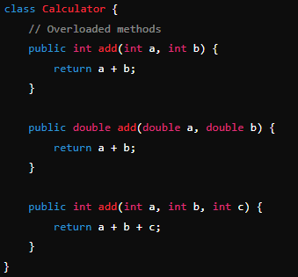
Polymorphism
Polymorphism is one of the core concepts in Object-Oriented Programming (OOP), which allows an object to take multiple forms. In Java, it enables a single action or method to behave differently based on the object or data type invoking it. Polymorphism promotes flexibility and reusability in code. Types of Polymorphism:
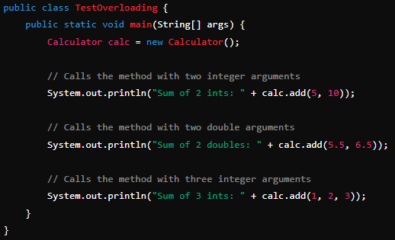
1. Compile-Time (Static) Polymorphism: Method Overloading Method overloading occurs when multiple methods in the same class share the same name but have different parameter lists (either by number, type, or order of parameters). The correct method to call is determined at compile time based on the method signature (name and parameter list). Key Points:
- It is resolved during compilation.
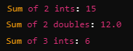
- Methods must have the same name but different parameter types or different numbers of parameters.

2. Run-Time (Dynamic) Polymorphism: Method Overriding
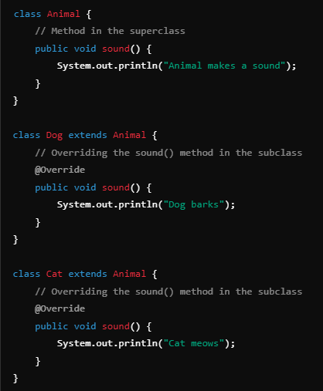
Method overriding happens when a subclass provides a specific implementation for a method that is already defined in its superclass. The version of the method that gets executed is determined at runtime, based on the object type. Key Points:
- It is resolved during runtime.
- The method in the subclass must have the same name, return type, and parameter list as the method in the superclass.
- The overriding method must not have a more restrictive access level than the method being overridden.
Example:
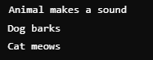
Here, the sound() method is overridden in both the Dog and Cat subclasses, and the method that gets executed depends on the actual object type at runtime, demonstrating dynamic polymorphism.
Aspect | Compile-Time Polymorphism | Run-Time Polymorphism
Definition | Method overloading: Same method name, different parameters. | Method overriding: Subclass provides specific implementation of a method.
Binding Time | Resolved at compile time (early binding). | Resolved at run time (late binding).
Achieved By | Overloading methods. | Overriding methods.
Inheritance Requirement | Not required. | Required.
Performance | Faster due to compile-time resolution. | Slightly slower due to runtime method lookup.
Example | add(int a, int b) and add(float a, float b). | Overriding toString() in a subclass.
Flexibility | Less flexible since behavior is determined at compile time. | More flexible as behavior can change dynamically at runtime.

Bottom of FormUpcasting and Downcasting
1. Upcasting: Upcasting is the process of converting a subclass type to its superclass type. It is automatically performed by the compiler, as the subclass is a more specific type, and the superclass is more general.
Why Use It? It allows you to use polymorphism, where a superclass reference can refer to any subclass object. This is useful for writing flexible code that works with superclass types but can handle different subclass objects. Key Points:
- Upcasting is implicit (automatic) in Java.
- The reference type becomes the superclass, but the object is still of the subclass type.
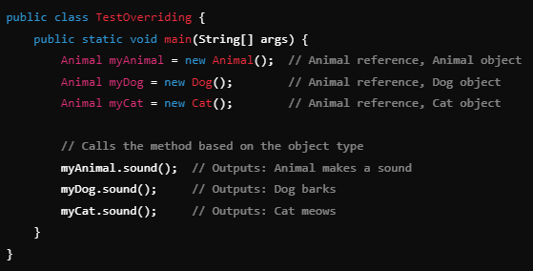
- Only the methods available in the superclass can be accessed, but overridden methods in the subclass are called.
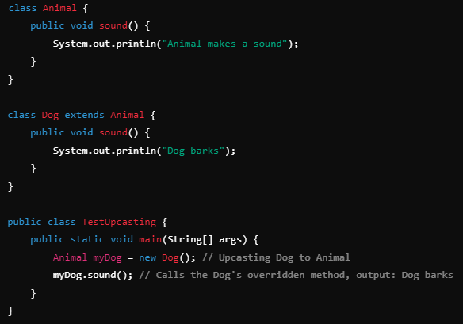
2. Downcasting: Downcasting is the process of converting a superclass type to a subclass type. Unlike upcasting, downcasting must be done explicitly using casting syntax. Why Use It? It is used when you want to access specific methods or properties of a subclass that are not available in the superclass. Key Points:
- Downcasting requires explicit casting using the () operator.
- It's necessary to ensure that the object is actually an instance of the subclass, or a ClassCastException will be thrown.
Example:
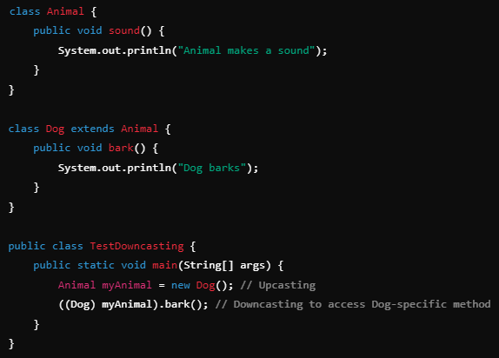

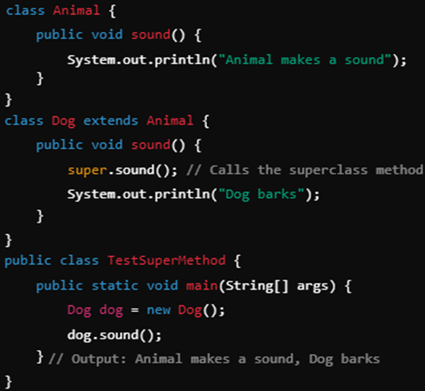
super Keyword
The super keyword is used to access members (methods or variables) of the parent class (superclass) from within a subclass. It can be used in three main contexts: calling superclass methods, accessing superclass variables, and calling superclass constructors.
- super.method(): Used to call an overridden method of the parent class.
- super.variable: Accesses a hidden variable in the parent class.
- super() constructor: Invokes the parent class constructor (must be the first line in the subclass constructor).
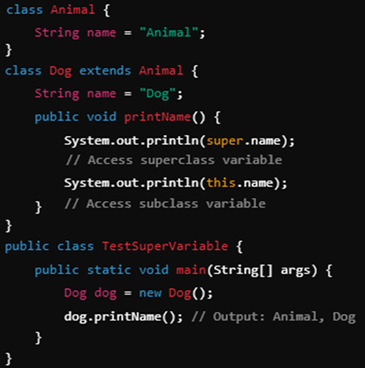
- Accessing Superclass Methods: The super keyword is used to invoke the overridden method in the superclass.

- Accessing Superclass Variables: The super keyword can be used to reference variables of the superclass if they are hidden by the subclass variables.

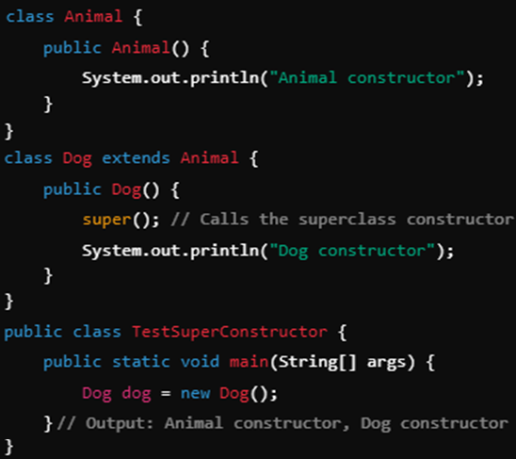
- Calling Superclass Constructors: The super() constructor call is used to invoke the parent class constructor. It must be the first statement in the subclass constructor.
Example:

Polymorphism in Interfaces
Polymorphism in interfaces refers to the ability of a class to implement multiple interfaces, enabling it to exhibit different behaviors depending on the interface used. In Java, interfaces define a contract of methods that any implementing class must provide, promoting loose coupling and flexibility in the system.
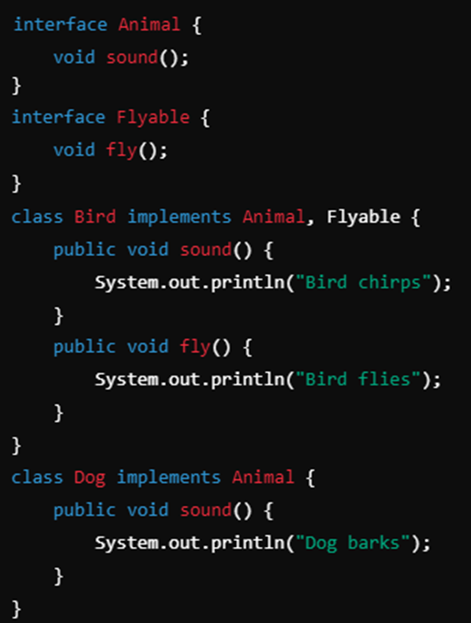
- Classes can implement multiple interfaces to provide different behavior depending on the interface used.
- Interface references can hold objects of different classes that implement the same interface, enabling runtime polymorphism.
- This promotes flexibility and modular design in systems, as different classes can implement the same interface in their unique ways.
Role of Interfaces in Polymorphism:
- Multiple Implementations: A class can implement multiple interfaces, allowing it to take on different forms (polymorphism) based on the interface reference.
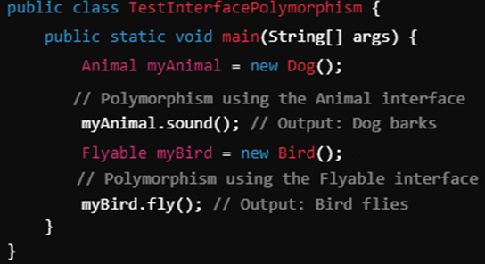
- Method Generalization: By programming to an interface, you can treat objects of different classes uniformly, provided they implement the same interface. This promotes the open-closed principle (OCP) in OOP.

Abstract Classes and Polymorphism
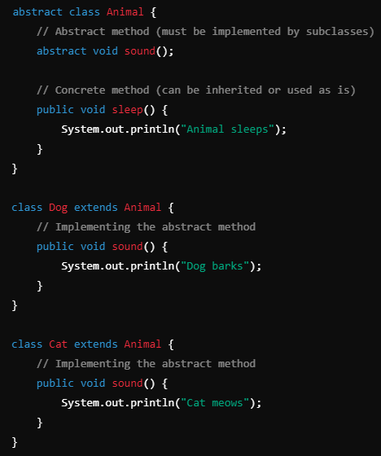
Abstract classes allow polymorphism by providing a common base class with abstract methods that must be implemented by any non-abstract subclass. This mechanism forces subclasses to provide specific implementations for the abstract methods, while still allowing shared behavior through non-abstract methods.
- Abstract classes allow runtime polymorphism through method overriding.
- Subclasses must provide specific implementations for abstract methods, but they can also use or override non-abstract methods in the abstract class.
- Abstract classes are particularly useful when you want to provide a common template (shared behavior) but leave specific details to the subclasses.
- Unlike interfaces, abstract classes allow partial implementation (having both abstract and concrete methods).
How Abstract Classes Enable Polymorphism:
- Partial Implementation: Abstract classes can provide partial method implementations, allowing subclasses to inherit common functionality and override or implement additional behaviors.
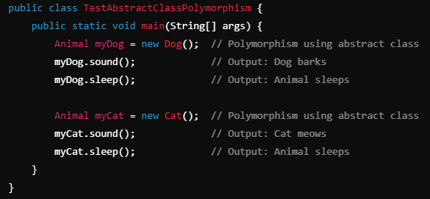
- Runtime Polymorphism: Abstract classes enable polymorphism because you can use the abstract class reference to hold an instance of any subclass, which allows dynamic method dispatch (overridden methods in the subclass are called at runtime).

Advantages of Polymorphism in Object-Oriented Programming (OOP)
- Code Reusability: Polymorphism allows you to reuse code by using a common interface or superclass, reducing redundancy in your programs.
- Flexibility: It provides flexibility by enabling one object to take multiple forms, allowing different implementations of methods depending on the object type at runtime.
- Simplified Code Maintenance: By using polymorphism, you can easily extend or change the behaviour of a class without affecting existing code, improving maintainability.
- Loose Coupling: Polymorphism reduces dependency between classes, promoting loose coupling, which makes your code more modular and easier to manage.
- Extensibility: New classes can be added with minimal changes to existing code, if they follow the same contract (interface or superclass).
- Dynamic Method Dispatch: With polymorphism, the decision of which method to invoke is made at runtime, allowing more dynamic and context-specific behaviour in your programs.
- Improved Readability and Clean Design: Using polymorphism leads to cleaner code with fewer conditionals (like if or switch statements) to check object types, making code more readable.
- Easier Code Testing: Since polymorphic objects are treated in a uniform way, testing different components becomes easier by substituting objects without affecting overall functionality.
- Increased Productivity: Polymorphism enables developers to implement changes and add new features faster due to the modularity and extensibility it offers.
- Interface Generalization: It allows you to create generalized code that works with multiple types, promoting the use of interfaces and abstract classes to define standard behaviour.

Encapsulation
Encapsulation is one of the core principles of Object-Oriented Programming (OOP). It refers to the bundling of data (variables) and methods (functions) that operate on that data into a single unit, typically a class. By doing so, it restricts direct access to some of an object’s components and only allows controlled access through well-defined interfaces (methods).
The primary purpose of encapsulation is to hide the internal workings (data and implementation details) of a class from the outside world, exposing only the necessary functionalities. This is achieved by:
- Making the class variables private.
- Providing public getter and setter methods to access and modify these private variables.
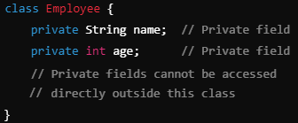
This concept enhances data security by preventing unauthorized or accidental modifications to an object’s internal state, thereby protecting the integrity of the object. Additionally, encapsulation makes it easier to maintain and update code because changes to the internal implementation don't affect how other parts of the code interact with the object.

Private Access Modifier
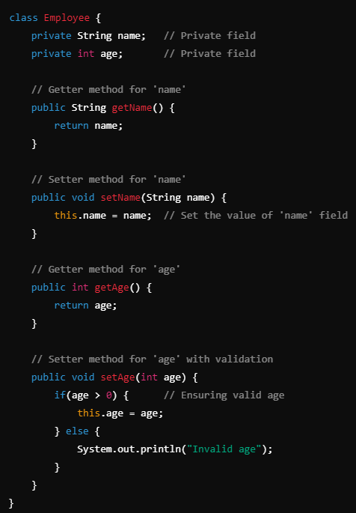
In Java, the private access modifier is used to restrict access to a class’s fields and methods. When a class member (such as a variable or method) is declared private, it can only be accessed within the same class. This prevents direct manipulation or retrieval of the member from outside the class, ensuring controlled access and protecting the object’s state.
Getter and Setter Methods:
Since the private access modifier prevents direct access to fields from outside the class, getter and setter methods are introduced to provide controlled access to these private fields. These methods are typically declared as public so that external classes can access and modify the private fields indirectly, ensuring that appropriate validation or constraints can be applied before updating or retrieving the values.
- Getter: A method used to retrieve (or "get") the value of a private field.
- Setter: A method used to modify (or "set") the value of a private field, often with validation.
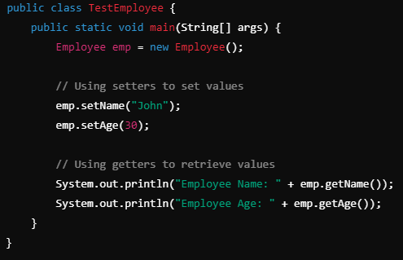
Benefits of Using Getters and Setters:
- Controlled Access: Provides a layer of control over how class fields are accessed and modified.
- Validation: Enables validation logic before modifying a field. For example, you can prevent setting a negative age by adding conditions in the setter.
- Flexibility: You can change the internal implementation without affecting external code. For instance, you can change how the name is stored (e.g., formatting) without altering the external code using the getName() method.
- Data Security: By making fields private and using controlled methods, you enhance the security of sensitive data.

Benefits of encapsulation
- Data Hiding: Encapsulation hides a class’s internal implementation, exposing only necessary functions and protecting sensitive data.
- Increased Security: Restricts direct access to an object's state, ensuring data integrity.
- Controlled Access: Uses getter and setter methods for controlled variable access, allowing validation.
- Improved Flexibility: Internal changes don’t affect external code, as implementation is hidden.
- Easier Maintenance: Isolates changes within a class, reducing the impact on the rest of the application.
- Reduced Complexity: Simplifies interfaces by hiding complex internal processes.
- Enhances Modularity: Divides the system into manageable units for independent development and testing.
- Prevents Data Corruption: Controls variable access to avoid accidental data modification.
- Improved Code Reusability: Allows classes to be reused without exposing implementation details.
- Supports Abstraction: Lets users focus on what an object does, not how it works, simplifying usage.

static Keyword in Java
The static keyword in Java is used for memory management and can be applied to variables, methods, blocks, and nested classes.
- Static Variables (Class Variables): A static variable is shared among all instances of a class. Instead of each object having its own copy, a single copy of the static variable is created and shared.
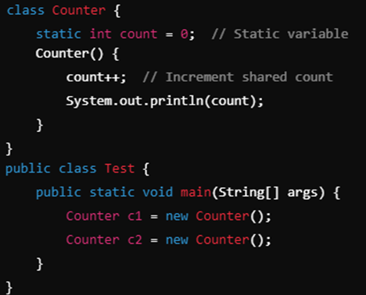
- Static Methods: Static methods belong to the class, not to objects. These methods can access static variables but cannot access non-static instance variables or methods.
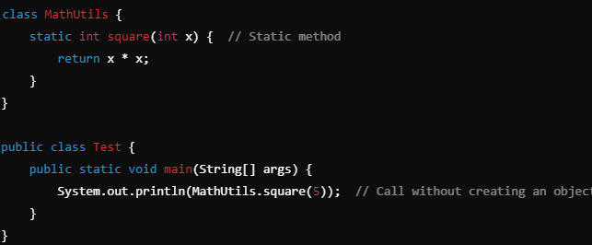
- Static Blocks: Static blocks are used for static initializations of a class. This block of code runs once when the class is loaded into memory.
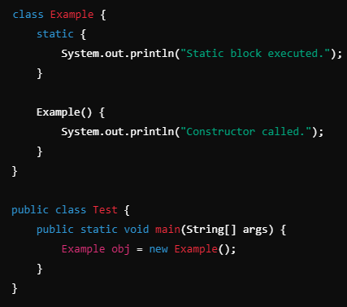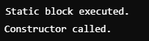
- Static Classes: You can define a static nested class. A static nested class does not have access to instance variables or methods of the outer class.
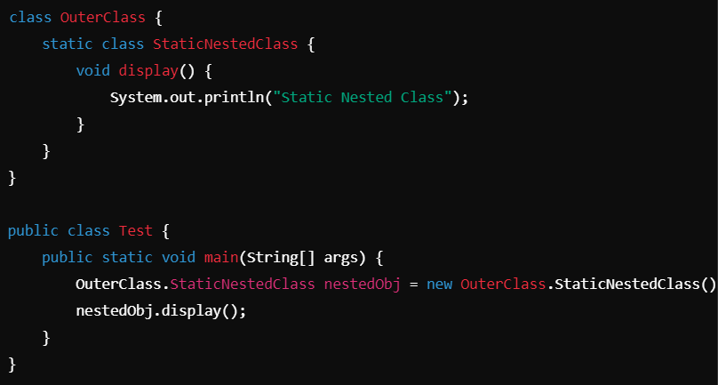

final Keyword in Java
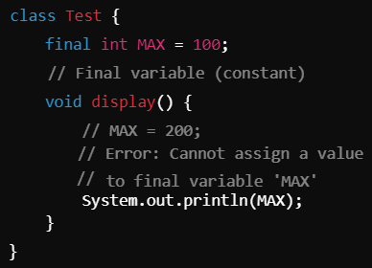
The final keyword in Java is used to declare constants or to prevent inheritance and method overriding. It can be applied to variables, methods, and classes.
- Final Variables: A final variable can be assigned only once, making it a constant. Once assigned, its value cannot be changed.

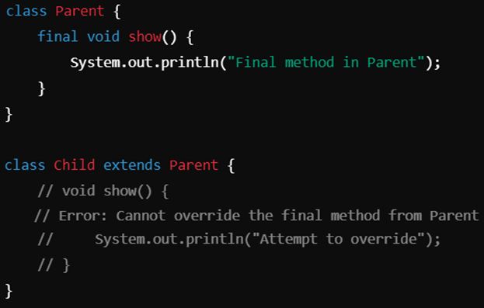
- Final Methods: A method declared as final cannot be overridden by subclasses.

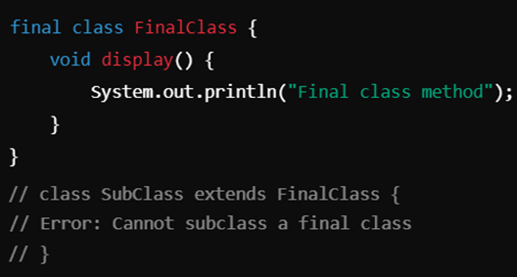
- Final Classes: A class declared as final cannot be subclassed. This means no class can extend a final class.

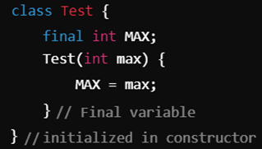
- Blank Final Variable: A final variable can be initialized later but only once. This is called a blank final variable.

Wrapper Classes
Wrapper classes in Java are classes that encapsulate (or "wrap") primitive data types into objects. This allows primitives to be treated as objects, which is essential for certain operations, especially in the context of Java's Collections Framework. Each primitive data type has a corresponding wrapper class.
Purpose
- Object Representation: Wrapper classes allow primitive data types to be represented as objects. This is necessary for certain data structures and frameworks that require objects, such as collections.
- Method Compatibility: They provide methods for converting between different data types and for manipulating primitive values.
- Enhanced Functionality: Wrapper classes come with utility methods that enhance the capabilities of primitive types, such as parsing and conversion.
Primitive Type | Wrapper Class
byte | Byte
short | Short
int | Integer
long | Long
float | Float
double | Double
char | Character
boolean | Boolean
Key Features of Wrapper Classes:
    - Conversion Between Primitives and Objects:
      - Boxing: Converting a primitive value into a corresponding wrapper class object.
      - Unboxing: Converting a wrapper class object back to a primitive value.
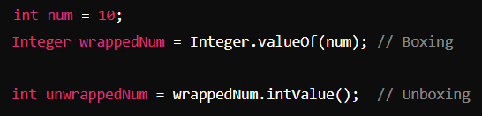
    - Autoboxing and Autounboxing:
      - Java provides a feature called autoboxing, which automatically converts a primitive type into its corresponding wrapper class when needed.
      - Autounboxing automatically converts a wrapper class object back to its corresponding primitive type.
    - Methods and Utilities: Wrapper classes provide useful methods to work with the values, such as parsing strings into numbers, comparing values, and more. Examples:
      - Integer.parseInt("123"): Converts a string to an int.
      - Double.toString(10.5): Converts a double to a String.
      - Character.isDigit('5'): Checks if a character is a digit.
    - Immutable: Wrapper class objects are immutable, meaning once a wrapper object is created, its value cannot be changed. If you need a different value, a new wrapper object must be created.
    - Constants: Wrapper classes contain useful constants, such as Integer. MAX_VALUE, Double. POSITIVE_INFINITY, etc., which represent the limits and special values of the corresponding primitive types.
Example Usage:
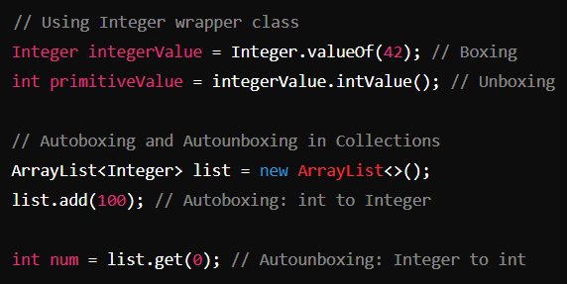
Types of Wrapper Classes of 8 primitive data types:
Wrapper Classes | Usage | Example
Integer | Commonly used in collections (e.g., List<Integer>). | Integer num = Integer.valueOf(10);
Double | Useful for mathematical operations in collections. | Double num = Double.valueOf(10.5);
Float | Used in floating-point arithmetic with collections | Float num = Float.valueOf(5.5f);
Long | Useful for large integer values in collections | Long num = Long.valueOf(100000L);
Short | Useful for smaller integer values in collections | Short num = Short.valueOf((short) 10);
Byte | Useful for byte-level data manipulation | Byte num = Byte.valueOf((byte) 1);
Character | Useful for handling character data in collections | Character letter = Character.valueOf('A');
Boolean | Useful for conditions and flags in collections | Boolean flag = Boolean.valueOf(true);
Methods of Wrapper Classes
Wrapper classes in Java come with several utility methods to manipulate and convert primitive data. Some commonly used methods are:
  - valueOf(): Converts a string or primitive type to the corresponding wrapper object. Example: Integer.valueOf("10"); (returns an Integer object).
  - parseXxx(): Converts a string to the corresponding primitive data type. Example: Integer.parseInt("10"); (returns an int).
  - toString(): Converts the wrapper object into a String representation. Example: Integer.toString(10); (returns the string "10").
  - xxxValue(): Returns the value of the wrapper object as its corresponding primitive type. Example: Integer obj = 10; obj.intValue(); (returns the int 10).
  - compareTo(): Compares two wrapper objects. Example: Integer num1 = 5; Integer num2 = 10; num1.compareTo(num2); (returns a negative number because 5 is less than 10).
  - equals(): Compares two wrapper objects for equality. Example: Integer num1 = 5; Integer num2 = 5; num1.equals(num2); (returns true).
  - hashCode(): Returns a hash code value for the wrapper object. Example: Integer num = 5; num.hashCode();.
Immutable Nature of Wrapper Classes
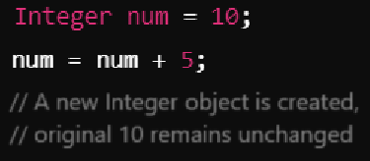
Wrapper classes in Java are immutable, meaning once an object of a wrapper class is created, its value cannot be changed. If any change is needed, a new wrapper object has to be created. This helps maintain the integrity of data, ensuring values don't get accidentally altered. Benefits:
- Thread-Safety: Immutable objects are inherently thread-safe since their state cannot change after creation.
- Consistency: Immutable objects ensure the integrity and consistency of data throughout the program.
Feature | Primitive Data Types | Wrapper Classes
Memory Usage | Use less memory, hold direct values. | Use more memory, represent as objects.
Performance | Generally faster, no object overhead. | Slower due to object creation and boxing/unboxing.
Nullability | Cannot be null, have a default value (e.g., 0). | Can be null, allowing representation of absence of value.
Flexibility | Limited operations (e.g., arithmetic). | Provide utility methods for type conversion, comparison, etc.
Usage in Collections | Cannot be used directly in collections (e.g., List, Set). | Can be used in collections (e.g., List<Integer>, Set<Double>).
Type Safety | Not type-safe in generics (cannot use primitive types). | Enforces type safety in generics (e.g., List<Integer>).
Object-Oriented Features | Cannot leverage OOP features directly. | Can use OOP features like inheritance, polymorphism.
Default Values | Has default values (e.g., 0 for int). | Default value is null when not initialized.
Conversion Methods | No built-in methods for conversion. | Comes with methods (e.g., parseInt(), valueOf()) for conversion.
Thread-Safety | Not inherently thread-safe. | Immutable and thread-safe (once created).
Importance of Wrapper Classes
- Integration with Collections: Wrapper classes allow primitive data types to be used in Java Collections Framework (e.g., List, Set, Map), which only work with objects.
- Utility Methods: They provide various utility methods for converting between types, parsing strings into primitives, and performing comparisons, enhancing the flexibility of data handling.
- Object-Oriented Features: Wrapper classes enable the use of object-oriented principles, allowing developers to leverage features like inheritance, polymorphism, and method overloading.
- Nullability: Unlike primitive types, wrapper objects can represent null, which is useful in scenarios where data may be absent, such as in database operations.
- Type Safety in Generics: Wrapper classes help ensure type safety in generic types, preventing runtime errors by enforcing the correct type at compile time (e.g., List<Integer>).
- Compatibility with Streams: They facilitate seamless integration with Java I/O operations, allowing primitive types to be handled as objects for serialization and deserialization.
- Object Representation: Wrapper classes enable the conversion of literals into object form, which is crucial for advanced operations like sorting and filtering in real-world applications.
- Enhanced Functionality: Wrapper classes support additional functionalities, such as immutability, which contributes to safer and more predictable code.

